BOLETÍN INFORMATIVO DE LA
COMISIÓN DE GEOSPELEOLOGÍA
Federación Espeleológica de América Latina y el Caribe
-FEALC-

[Geospeleology Commission Newsletter,
Speleological Federation of Latin America and the Caribbean -FEALC-]

No. 29, Octubre 2002

Coordinador: Prof. Dr. Franco Urbani
Sociedad Venezolana de Espeleología. Apartado 47.334, Caracas 1041A, Venezuela.
Telefax: (58)-212-272-0724, Correo-e: urbani@cantv.net

Este Boletín es de carácter informal -no arbitrado- preparado con el objetivo de divulgar rápidamente las actividades geoespeleológicas en la región de la FEALC. Sólo se difunde por vía de correo electrónico. Es de libre copia y difusión y explícitamente se solicita a quienes lo reciban que a su vez lo reenvíen a otros posibles interesados, o lo incluyan es páginas web. Todos los números anteriores están disponibles. Igualmente se pide que obtengan copias en papel para las bibliotecas de sus instituciones. Se solicitan contribuciones de cualquier tipo y extensión para su divulgación.

Índice

The sandstone karst of the Chapada Diamantina, NE-Brazil.
Jens Wiegand, Ivo Karmann & Michael Fey 1-2

Imágenes de cuevas en areniscas del estado de Paraná, Brasil
José Mário Budny 2-4

THE SANDSTONE KARST OF THE CHAPADA DIAMANTINA, NE-BRAZIL

Jens Wiegand*, Ivo Karmann⁺ & Michael Fey*

*University of Essen, Department 9 - Geology, 45141 Essen, Germany, jens.wiegand@uni-essen.de
⁺University of Sao Paulo, Instituto de Geociências USP, 05508-900 São Paulo SP, Brazil, ikarmann@usp.br

The genetic processes and developments of the so-called quartzite or sandstone karst are widely unexplained. It is difficult to imagine that monomineralic rocks build up nearly totally from chemical resistant quartz, develop all the karstic features known from limestone areas. There are not many locations in the world where a sandstone karst was developed; nearly all of them are within the tropics. Up to know, hardly ever geochemical and hydrochemical investigation about sandstone karst were conducted, but there are some geomorphological investigation.
In August and September 1999 investigation of Brazilian sandstone karst were conducted in a co-operation between the University of Essen and the University of Sao Paulo. The working areas are the sandstone karst of the Chapada Diamantina (Bahia State), and to a lesser extent, the quartzite karst of the Itacolomi massif (Minas Gerais). In both areas, caves up to 1600 m could be investigated, and in the Chapada Diamantina, even new caves were discovered. Rock and soil samples in different states of weathering, as well as water samples (soil water, surface water, cave water) were collected.
At the moment, we are finishing the analysis and compile the results. Our main focus lies on the role of humic acids in the process of quartz leaching, because in the range of recent pH values, the solubility of quartz is very small. Tropical plants can have up to 10 dry-weight % SiO₂; this points clearly to a biogene mechanism, with which plants can take up large amounts of SiO₂ (i.e. organic Si-complexes). The high content of TC (total carbon) and DOC (dissolved organic carbon) in the analysed waters underline this assumption. But even with the aid of humic acids the processes of karst development must be very slow.
Beside rock and water samples, speleothemes build up from opal could be sampled too. Normally, opal speleothemes reach dimensions of several centimetres. In the Chapada Diamantina speleothemes of up to 1 m (!) were discovered and samples were taken very carefully and limited. Additionally, very thin-laminated opal crusts were discovered along cave floors. We assume that the very slow-growing opal speleothemes must be very old and reach back into Tertiary age. The slow processes of karst development in sandstones and quartzites points to an old age of speleothemes too.
We are now looking for a possibility to date the opal speleothemes and to analyse them in respect to stable isotopes. We want to encourage and welcome colleagues, who are interested in our findings to co-operate with us.
Copied from: http://www.uni-essen.de/geologie/abs/abs28.htm

--------------------------

IMÁGENES DE CUEVAS EN ARENISCA DEL ESTADO DE PARANÁ, BRASIL

José Mário Budny. Brasil. jmbudny@uol.com.br
.
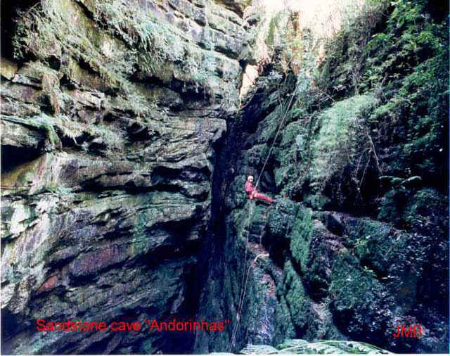
Cueva "Andorinhas". Ubicación:- Lat. 25° 08' 38" S - Lon. 49° 55' 57" W - alt. 1080 m. Comarca Ponta Grossa - Paraná - Brasil. Litologia: Arenito Furnas. Desenvolvimento Linear 161m - Desnivel 58m

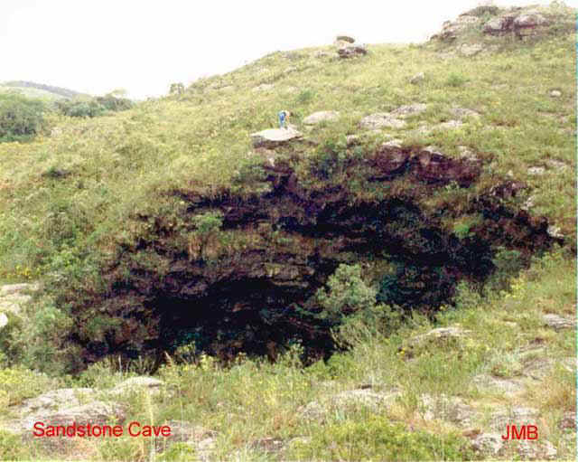
Cueva "Buraco do Padre". Ubicación:- Lat. 25º 10' 16" S - Lon. 49° 58' 12" W - alt. 940 m. Comarca Ponta Grossa - Paraná - Brasil. Litologia: Arenito Furnas. Desenvolvimento Linear 40m - Desnivel 43m

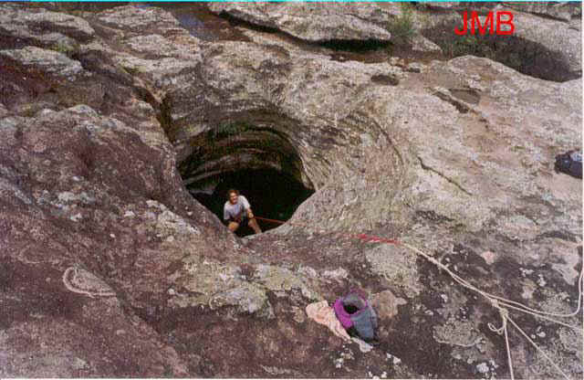
Cueva "Lageado do Sobrado" - Acesso Dolina. Ubicación:- Lat. 25° 21' 14.7" S - Lon. 49° 52' 28.3" W - alt. 881 m. Comarca Palmeira - Paraná - Brasil. Litologia: Arenito Furnas. Desenvolvimento Linear 70m
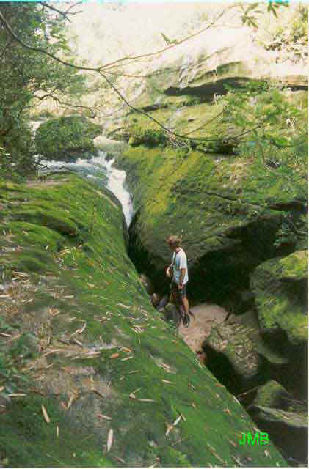
Cueva "Lageado do Sobrado" (Sumidouro).

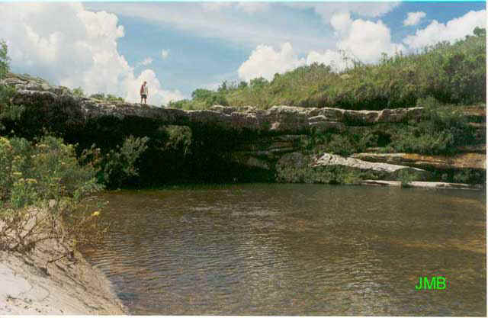
Cueva "Lageado do Sobrado" (Ressurgencia). Distancia entre Sumidouro e Ressurgencia:- 270 m
Copiado de: http://karst.planetresources.net/sandstone_caves-gallery.htm
(También ver el trabajo previo: “Imágenes de una cueva en arenisca, Paraná, Brasil: La Cueva Lindolfo”. José Mário Budny. Boletín Informativo de la Comisión de Geospeleología, Federación Espeleológica de América Latina y el Caribe -FEALC- [Geospeleology Commission Newsletter, Speleological Federation of Latin America and the Caribbean -FEALC-] , 25: 1-2. Feb. 2002

