BOLETÍN INFORMATIVO DE LA
COMISIÓN DE GEOSPELEOLOGÍA
Federación Espeleológica de América Latina y el Caribe -FEALC-

[Geospeleology Commission Newsletter,
Speleological Federation of Latin America and the Caribbean -FEALC-]

No. 33, Marzo 2003

Coordinador: Prof. Dr. Franco Urbani
Sociedad Venezolana de Espeleología. Apartado 47.334, Caracas 1041A, Venezuela.
Telefax: (58)-212-272-0724, Correo-e: urbani@cantv.net

Este Boletín es de carácter informal -no arbitrado- preparado con el objetivo de divulgar rápidamente las actividades geoespeleológicas en la región de la FEALC. Sólo se difunde por vía de correo electrónico. Es de libre copia y difusión y explícitamente se solicita a quienes lo reciban que a su vez lo reenvíen a otros posibles interesados, o lo incluyan es páginas web. Todos los números anteriores están disponibles. Igualmente se pide que obtengan copias en papel para las bibliotecas de sus instituciones. Se solicitan contribuciones de cualquier tipo y extensión para su divulgación.

Índice

The Pleistocene palaeontological site of Toca da Janela da Barra do
Antonião (Sao Raimundo Nonato, Piauí State, Brazil.
Claude Guerin, Martine Faure, Paulo R. Simões,
Marguerite Hugueney & Cécile Mourer-Chauvire 1-10

Copied from: http://www.unb.br/ig/sigep/sitio069/sitio069english.htm


Geological and Paleontological Sites of Brazil - 069
The Pleistocene Palaeontological
Site of Toca da Janela da Barra do Antonião
(São Raimundo Nonato, Piauí state)
Date:27/10/1999
Claude Guerin *
guerin@cismsun.univ-lyon.fr
Martine Faure **
martine.faure@lyon.mom.fr
Paulo R. Simões ***
fumdham@zaz.com.br
Marguerite Hugueney *
m-hugue@cismsun.univ-lyon.fr
Cécile Mourer-Chauvire *
mourer@cismsun.univ-lyon.fr
*The Centre for Stratigraphical Palaeontology and Palaeoecology associated with CNRS (UMR 5565), UFR of Earth Sciences, Claude Bernard University – Lyon I, 27-43 Boulevard du 11 Novembre, 69622 Villeurbanne Cédex, France , and Fundação Museu do Homem Americano, São Raimundo Nonato, Piauí, Brazil.
** UMR 5565 e Universidade Lumière-Lyon 2, 7 rue Raulin, 69007 Lyon, França, e Fundação Museu do Homem Americano, São Raimundo Nonato, Piauí, Brasil.
** UMR 5565 Lumière-Lyon University 2, 7 rue Raulin, 69007 Lyon, France and Fundação Museu do Homem Americano, São Raimundo Nonato, Piauí, Brazil.
*** Fundação Museu do Homem Americano, São Raimundo Nonato, Piauí, Brasil. Rua Abdias Neves, 551 64770-000 São Raimundo Nonato - PI
© Guerin,C.; Faure,M.; Simões,P.R.; Hugueney,M.; Mourer-Chauvire,C. 1999. The Pleistocene Palaeontological Site of Toca da Janela da Barra do Antonião (São Raimundo Nonato, Piauí state). In: Schobbenhaus,C.; Campos,D.A.; Queiroz,E.T.; Winge,M.; Berbert-Born,M. (Edit.) Sítios Geológicos e Paleontológicos do Brasil. Published on Internet at the address http://www.unb.br/ig/sigep/sitio069/sitio069.htm
(The above bibliographic reference of author copy rights is required for any use of this article in any media, being forbidden the use for any commercial purpose)

ABSTRACT
In the Southeast of Piauí, a karstic area of reduced dimensions is home to a large number of hollows containing archaeological and palaeontological remains and palaeoclimatic indicators. These hollows, which are situated in the vicinity of the Serra da Capivara National Park, are directly related to the other archaeological sites in the region. The site at Toca da Janela da Barra do Antonião stands out as the main site of the carstic region where excavations have uncovered evidence of a rich pleistocene fauna, human burial, rock paintings and stone material associated with the megafauna. Taken together, the analysis of these remains will enable a greater understanding of Brazilian pre-history and of the evolution of Brazil’s natural environments.

INTRODUCTION
Toca da Janela da Barra do Antonião is the most important site in the carstic area located in the São Raimundo Nonato region of the Southeast of Piauí. It is found in a residual carste situated in the south of the Serra de Capivara National Park where there are other hollows with fossiliferous deposits. Since 1986, research carried out in the carstic region has provided evidence for a rich pleistocene fauna, with Holocene remains very often including connected skeletons. The presence was also noted of micro-mammals, diverse bird life, crocodilians, chelonians, lithic material associated with the bones of mega-mammals, bones showing evidence of having been used, burials and rock paintings. Excavations carried out at Toca do Garrincho, Toca de Cima do Pilão and Toca do Serrote do Artur showed evidence of material of a similar nature, which led us to presume that they were relatively contemporaneous.
These excavations revealed 50 taxa of mammals, of which 20 are extinct. The pleistocene mega-mammals and the birds are well represented, thus showing that open areas predominated in the region, with an abundant herbaceous stratum, substantial forested areas, lower annual average temperatures than are experienced today and a larger hydro-circulation.
The sedimentological study of the chemical and physical deposits and the establishment of their chronology, the micrographic study, the anthracological, palynological and malacological analyses, as well as the study of the biostratigraphic, biogeographic and biochronological relations, together contribute to the hope that a better understanding will be gained of the palaeo-environmental context of a culturally rich and diverse region.
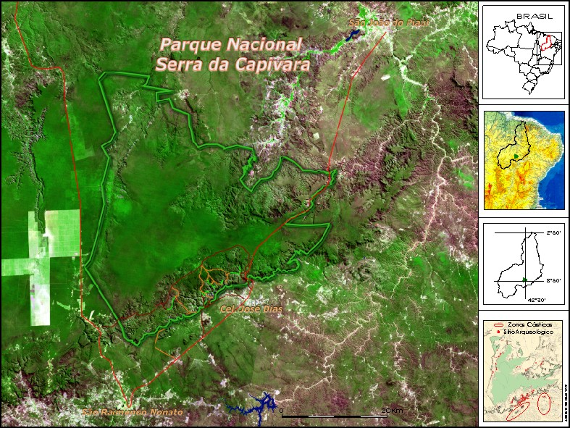
Figure 1 : General View of Serra da Capivara National Park
LOCATION
Situated in the Southeast of the State of Piauí, in the region known as "Polígono das Secas" ("The Drought-ridden Polygon"), the Archaeological Area of the Serra da Capivara National Park encompasses and protects in excess of 400 archaeological and palaeontological sites. Taken as a whole, the research projects carried out here have provided a source of data that will enable a greater understanding of Brazilian pre-history (Arnaud et al, 1984).
The area corresponds to the region between Southerly latitudes 8° and 9°30’ and between Easterly longitudes 30° and 43°30’, with a land area of 40,000 km². It possesses a dry climate of type BShw (Koppen). Precipitation is irregular in terms of both location and time of occurrence, with annual averages of around 650mm. The rainy season generally occurs between October and the end of April. Rainfall is typically localised and brief. The annual potential evapo-transpiration is estimated at approximately 1400 mm, according to the Thornthwaite method.
The annual average temperature is high (28°C), with an annual range of temperature variation of about 5°C. The coldest month is June, with a minimum temperature of 12°C, a maximum of 35°C and an average of 25°C. The beginning of the rainy season is the hottest period of the year, with an average of 31°C, maximum temperatures of 45°C and minimum temperatures of 22°C. Bushy scrub that is difficult to penetrate is the characteristic vegetation of the region, but areas of forest occur in the ravines, where the largest concentrations of water are to be found.
Two major geomorphological territories are found in the region. To the South lies the Peripheral Depression of the São Francisco, with Pre-Cambrian tectonic and migmatized rocks that constitute its crystalline foundation. To the North, a second territory is made up of the sedimentary rocks of the Parnaíba Basin, which date from the Palaeozoic and Mesozoic. The relief of the Peripheral Depression of the São Francisco, with altitudes reaching about 400m, is characterised by a vast plain from which rise up gneissic and quartzite inselbergs, intrusive granite batholiths, smooth micaceous rocks as well as metamorphosed limestone outcrops. The relief of the sedimentary rocks of the the Parnaíba Basin forms a extensive flat surface, the altitudes of which range between 500m and 650m, generally terminating in abrupt escarpments. This landscape has a rugged appearance owing to its easily fractured structure, forming gullies, towers and arcs. It is in these gullies that the largest concentration of archaeological sites containing rock paintings has been found in this region, having been researched since 1970 by the Franco-Brazilian Mission of Piauí. In 1979, the Serra da Capivara National Park was created, and was later declared to be part of the Cultural Heritage of Mankind by UNESCO in 1991. Conservation and research policies were consolidated following the creation of Fundação Museu do Homem Americano (The Museum of American Man Foundation) – FUMDHAM – in 1986. The National Park and its surroundings are jointly administrated by FUMDHAM and IBAMA. The Serra da Capivara National Park encompasses an area of 130,000 hectares, and falls variously within the local administrative regions of São Raimundo Nonato, Coronel José Dias, João Costa and Brejo do Piauí. Its southern flank is defined by the line of cuesta, an abrupt escarpment varying in height from 80m to 150m. In front of the cuesta, at a distance of a few kilometres, two karstic zones stand out in the landscape, rising nearly 100m above the level of the plain.
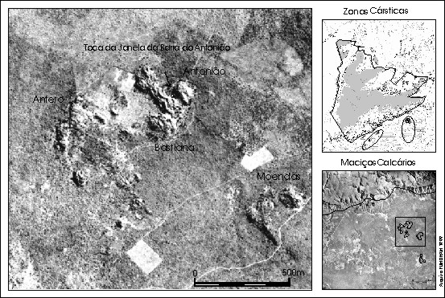
Figure 2 : View of Karstic Area
HISTORY
The karstic zones consist of a residual karst, made up of various small hills, amidst which are found a hundred or so hollows including archaeological and palaeontological sites. These two karstic zones are considered to be a single geological unit, where the separate hills are small limestone plates tilted upwards due to a phase of tectonic pressure. The karst of the Archaeological Area of São Raimundo Nonato displays a rugged surface, generally bare of vegetation, with small hollows owing to the tectonic separation and segmentation of the solid outcrops. It occurs in a calcitic, micro-crystalline, finely-stratified, metamorphic rock. Research into these sites, which are so favourable to the preservation of fossils, began in 1986 and has revealed a rich pleistocene fauna, rock paintings, burials, as well as stone and ceramic material. Excavations have taken place at Toca do Garrincho, Toca de Cima dos Pilão, Toca do Serrote do Artur, and significantly at Toca da Janela da Barra do Antonião, currently the most important palaeontological site in the region (Guérin et al, 1993, 1996). Its proximity to the line of the cuesta places it within the spatiofunctional complex of Toca do Boqueirão do Sítio da Pedra Furada, a key archaeological site in the region with human occupation reaching back to 50,000 B.P. Following its discovery in 1986, this site was excavated until 1990 by Niède Guidon (Guidon et al, 1993). Various human occupations, including stone industry and bones showing marks of human origin, were discovered. In July 1990, the remains of the skeleton of a particularly delicate young woman of small stature were found (pieces of skull, an incomplete jaw bone, long bones, carpus and metacarpus, vertebrae, and ribs). They were discovered under enormous fallen blocks in the upper part of the deposit and were dated as being 9700 years of age ( Peyre, 1993 ).

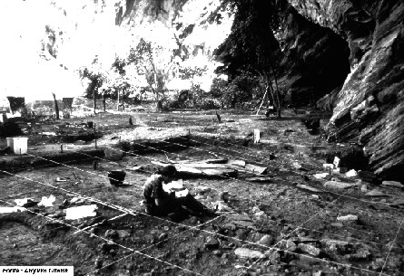
Figure 3 - The site under excavation
DESCRIPTION OF THE SITE
Toca Da Janela Da Barra Do Antonião is located at 08º48’09"S - 42º25’01"W (Barragem map 1/100 000). Its orientation is SE/NW and it is open to the NE. It is situated in the Serrote do Antonião, the largest limestone solid rock formation in the zone, extending 600m N/S and 450m E/W, with an area of 0.3 km². The base of the site is below the surrounding level of sedimentation, thus acting as a point of convergence for surface water in the rainy periods and contributing to the formation of fossil deposits. This hollow constitutes a vast shelter under rock oriented to the North. It has a width of 180m, a depth of 28m, and a deposit of up to 8m in depth. The excavated surface, which extends over 750m², was divided into 4 sectors from East to the West: D, A, B and C. A trench of 72m in length was opened from the East to the West underneath and within the limits of the shelter. A regular slope may be observed towards the East. Effectively the whole wall of the shelter shows large orifices corresponding to the arrival of water along channels made during the rainy periods. The presence of numerous rock fragments consisting of materials originating outside the immediate vicinity (gneiss, quartzite), and the presence of bones, confirm this intra-karstic palaeo-circulation. On an initial analysis, the stone industry includes 1918 pieces, of which 394 are pebble tools (45 used, 227 pebbles retouched using one or various instances of retouching , 122 retouched pebbles –choppers, chopping-tools and polyhedrons) and 271 unused stones. We counted 142 flakes with a cortex and 214 without, among which 82 had not been retouched. The flake tools amount to 129: burins, scrapers, tools with engravings, etc. ; there are 74 flake fragments and 16 splinters. There are 199 cores and we counted 479 fragments of stones and undetermined objects. The used stones come primarily from sector A and then from sectors D, C and B. The retouched stones are divided among the various sectors according to the following distribution: 42% in A, 22% in C and D, and 14% in B. The flakes which had not been retouched, but had in some cases been used, were more numerous (50% in C, 33% in A, 9% in B and 8% in D) than those which had been retouched. The distribution of flake tools is as follows: 48% in C, 22% in A, 21% in D and 9% in B. The 199 cores have the following distribution: 37% in A, 34% in C, 23% in D and 6% in B. The main materials used are quartzite (53%), quartz (37%), arenite (4%), silex (1%), and other rocks (5%). A number of the artefacts were found together with the remains of the megafauna and at the same levels. Among the thousands of vertebrate remains (Guérin et al. 1993, 1996), it is possible to identify 42 species of mammal, approximately 30 species of bird, an unidentified species of Aligatorideo., some unidentified species of Chéloniens amongst which a large-sized terrestrial form shows similarities to the Geochelone, and the fish Plecostomus auroguttatus. Molluscs were also collected. The birds are the Tinamiformes Crypturellus noctivagus, C. parvirostris; the Ciconiiforme Theristicus caudatus; the Anseriformes Amazonetta brasiliensis, Cairina moschata; the Accipitriformes Accipiter bicolor, Polyborus plancus, Falco rufigularis, F. sparverius; the Galliforme Penelope superciliaris or P. jacucaca; the Gruiformes Porzana carolina, cf. Porphyrula, cf. Gallinule; the Columbiformes Columba picazuro, Zenaida auriculata, Columbina minata, C. picui, cf. C. talpacoti; the Psittaciformes Ara chloroptera, Aratinga leucophtalmus, cf. A. cactorum, cf. Amazona aestiva; the Strigiformes Tyto alba, Otus choliba, Glaucidium minutissimum, G. brasilianum, Ciccaba virgata, Rhynoptynx clamator or Ciccaba huhula; the Caprimulgiforme cf. Hydropsalis; the Apodiforme Streptoprocne zonaris; the Piciformes Colaptes melanochloros, Dryocopus lineatus or Campephilus melanoleucos; Passeriformes indet.
The mammals are the marsupials cf. Didelphis albiventris, Monodelphis domestica, Marmosa cf. cinerea; the ground sloths Catonyx cuvieri, Eremotherium lundi and Xenocnus sp.; the armadillo Dasypus sp.; the giant armadillo Pampatherium humboldti ; the glyptodonts Hoplophorus euphractus, Panochthus greslebini, Glyptodon clavipes; the bats Pteronotus parnellii, Tonatia bidens, Phyllostomus hastatus, Artibeus jamaicensis, Myotis sp., Molossus molossus, Tadarida brasiliensis, Holochilus brasiliensis; the rodents Akodon cf. cursor, Calomys callosus, Oryzomys cf. subflavus, Oryzomys sp., Thricomys apereoides, Kerodon rupestris, Galea spixii, Agouti paca; the carnivores Protocyon troglodytes, Cerdocyon thous, Canideo indet. cf. Speothos or Cerdocyon, Mustelidae indet., Felis yagouaroundi and Smilodon populator ; the Litopterna Macrauchenia cf. patachonica; the Notoungulados Toxodon sp.; the Proboscídeos Haplomastodon waringi; the Equideos Hippidion bonaerensis et Equus neogaeus; the Pecaris Dicotyles tajacu and Tayassu pecari ; the Camelideo Palaeolama niedae (Guérin & Faure, 1999); the deer Mazama gouazoubira , M. americana and a large unidentified deer cf. Blastocerus.
The gigantic Eremotherium is the animal in most abundance by a considerable margin, followed by Palaeolama, the Equideos and the Mastodon. The four genera Eremotherium, Catonyx, Haplomastodon and Equus show that this fauna is from the Upper Pleistocene. A detailed study of the evolution of each species over time would allow a more precise date to be given. The ecological community defined by the collection of fauna that was present possesses some very specific characteristics. The high proportion of very large species is testament to very abundant vegetation.
The high proportion of predators, the abundance of omnivores, the predominance of hypsodont herbivores over the brachyodonts, and that of the large land animals adapted to varying environments over those found only in forests, suggests a mixed landscape. Also noticeable is the surprising absence of large rodents such as Hydrochoerides, the Tapirs and the Primates. The ecological community of mammals during the Upper Pleistocene in the region of São Raimundo Nonato is characteristic of a savannah landscape, bushy in places and scattered with forested areas, with a much more humid climate than at present.

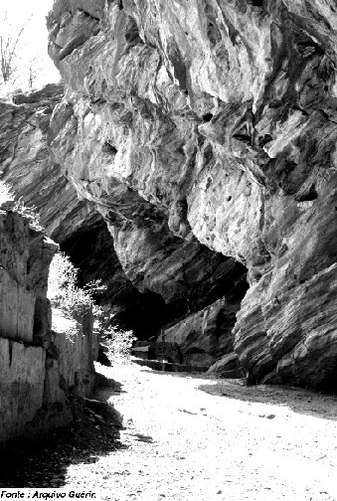
Figure 4 - View of the deposited filling
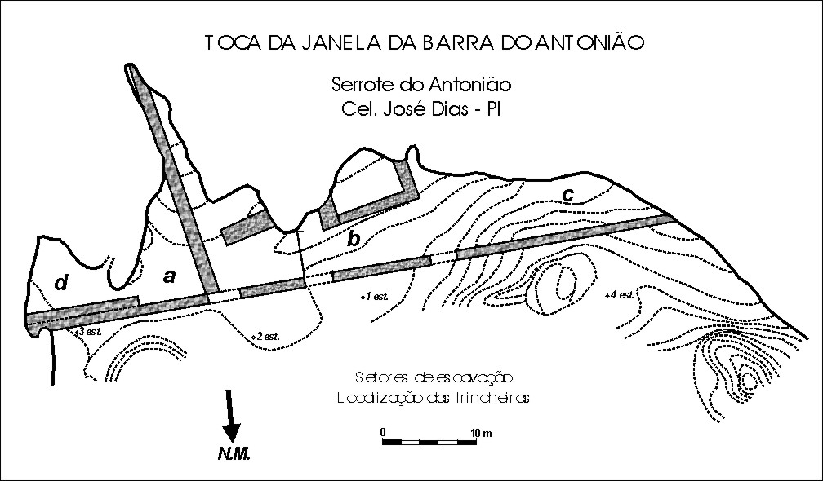
Figure 5 - Excavation plan
The excavations revealed various main horizons in the distribution of remains. The preliminary analysis of the groupings of material collected allowed us to compile, other than the dispersed bones and artefacts, 17 concentrations made up as much of lithic material as of bone material, or even more frequently of a mixture of both in very variable proportions. Their position varies from the rocky wall to the limits of the shelter's expanse, and their depth varies from 0 to 5.6 metres in sectors A (6 concentrations) and B (4 concentrations) and confirms the East to West slope of the deposited filling. Sector C (5 concentrations) is no longer fossiliferous beyond a depth of 2m. In Sector D, two concentrations of bones contain some lithic pieces and there are many dispersed bones to a depth of 2.99m.
As with the taphonomic observations, the preliminary studies of the sediment and of the current topography suggest the hypothesis that the deposited filling has a double origin in the following ways:
- on the one hand, lacustrine sedimentation, which involves the rapid burial of animal cadavers - the majority of which had died in the locality where they had come to drink - and which constitutes a commomplace observation of the current natural habitat. The discovery of various skeletons, either complete or fragmented but anatomically connected, is evidence for this occurrence.
- on the other hand, deposition under high energy favored by an intense karstic circulation: some bones are extremely rounded and other reduced to the condition of stones, sometimes mixed together with stones of rocks from outside the vicinity (quartz, metamorphic rocks); these rocks and these fossils arrived at the site due to the karst.
Toca da Janela da Barra do Antonião is the most important palaeontological site in the karst region of the archaeological area of São Raimundo Nonato. Its study will allow us to place South American palaeolithic man in his environment.
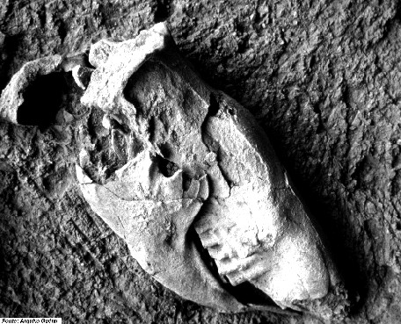
Figure 6 - The skull of the giant sloth Catonyx cuvieri
PROTECTION MEASURES
Unfortunately, these solid outcrops have been heavily damaged by the illegal production of lime, which has been occurring for more than two decades. It is calculated that around 50% of the surface of the solid outcrops have suffered from the impact of human activity. The removal of blocks for the construction of simple limekilns has been responsible for the destruction of hollows and rock paintings. This has had significantly negative consequences for the local flora because large quantities of timber have been felled in order to fire these kilns. At the same time, researchers have been impeded in their access to certain areas, and thus the progress of their work has been resticted.
A complete ban on this activity was achieved only in the middle of 1999. Given that this was an important activity for the local population, it is believed that the integrity of the ban can only be ensured through the implementation of alternative economic projects (Ecotourism, bee-keeping) allied to the adoption of a more effective protection and research strategy for the region.

BIBLIOGRAPHY
Arnaud,M.B.; Emperaire,L.; Guidon,N.; Pellerin,J. 1984. L’Aire archéologique du Sud-Est du Piauí (Brésil). Vol. 1: le milieu et les sites, Editions Recherche sur les Civilisations, "Synthèse" n° 16, 118 p., 9 fig., 2 tabl., 5 pl., 6 cartes h.t.

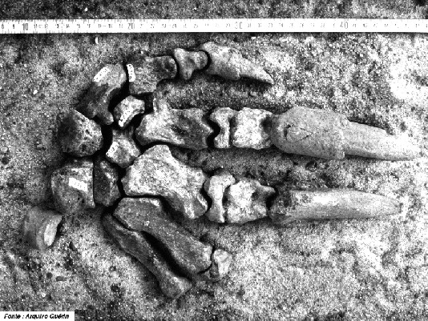
Figure 7 - The connected hand of Catonyx cuvieri
Guerin,C.; Curvello,M.A.; Faure,M.; Hugueney,M.; Mourer-Chauvire,C. 1993. La faune pléistocène du Piauí (Nordeste du Brésil): implications paléoécologiques et biochronologiques. Quaternaria Nova, Roma, III, p. 303-341, 3 tabl., 8 fig.
Guerin,C.; Curvello,M.A.; Faure,M.; Hugueney,M.; Mourer-Chauvire,C. 1996. The Pleistocene fauna of Piauí (Northeastern Brazil). Palaeoecological and biochronological implications / A fauna pleistocênica do Piauí (Nordeste do Brasil). Relações paleoecologicas e biocronologicas. Fumdhamentos (Revista da Fundação do Homem Americano), São Raimundo Nonato, vol. 1, n° 1, p. 55-103, 8 fig., 4 tabl., e discussões, p. 259-336 (bilingüe inglês/português) .
Guerin,C.; Faure,M. 1999. Palaeolama (Hemiauchenia) niedae nov. sp, nouveau Camelidae du Nordeste Brasilien, et sa place parmi les Lamini d’Amérique du Sud, Geobios, Lyon, n° 32, 4,p. 629-659, 11 fig., 12 quadros.
Guidon,N.; Luz,M.F.; Guerin,C.; Faure,M. 1993. La Toca de Janela da Barra do Antonião et les autres sites paléolithiques karstiques de l’aire archéologique de São Raimundo Nonato (Piauí, Brésil): état des recherches. Actes XIIème Congrès international Sciences préhistoriques et protohistoriques (Bratislava, septembre 1991), Bratislava, vol. 3, p. 483-491, 3 fig.
Peyre,E. 1993. Nouvelle découverte d’un homme préhistorique américain: une femme de 9700 ans au Brasil. C.R. Acad. Sci. Paris, sér. II, t. 316, p. 839-842.
Rodet,J. 1997. As zonas cársticas de São Raimundo Nonato (Piauí, Brasil). O carste, Belo Horizonte, vol. 9, n° 1, p. 2-7, 7 fig.

