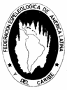
BOLETÍN INFORMATIVO DE LA
COMISIÓN DE GEOSPELEOLOGÍA
Federación Espeleológica de América Latina y el Caribe -FEALC-
- BICOMGEO - FEALC -
[Geospeleology Commission Newsletter,
Speleological Federation of Latin America and the Caribbean -FEALC-]

No. 42, Diciembre 2003

Coordinador: Prof. Dr. Franco Urbani
Sociedad Venezolana de Espeleología. Apartado 47.334, Caracas 1041A, Venezuela.
Telefax: (58)-212-272-0724, Correo-e: urbani@cantv.net

Este Boletín es de carácter informal -no arbitrado- preparado con el objetivo de divulgar rápidamente las actividades geoespeleológicas en la región de la FEALC. Sólo se difunde por vía de correo electrónico. Es de libre copia y difusión y explícitamente se solicita a quienes lo reciban que a su vez lo reenvíen a otros posibles interesados, o lo incluyan es páginas web. Todos los números anteriores están disponibles. Igualmente se pide que obtengan copias en papel para las bibliotecas de sus instituciones. Se solicitan contribuciones de cualquier tipo y extensión para su divulgación.

Índice

Cave Symbols - The Official UIS list 3-45

A proposition for Karst surface conventional symbols 45-49

Copied from http://www.karto.ethz.ch/neumann-cgi/cave_symbol.pl

Cave Symbols - The official UIS list

UIS working group on Cave Survey and Mapping

Symbol: Survey Points
Image Plan  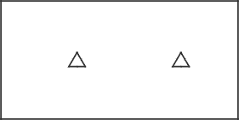 | Image Section

Explanation
The main survey points have been kept in the list, but often they are no longer shown on fair copies.

Translations
Croatian: Mjerne tocke
Dutch: Meetpunten
French: Point de relevé principal
German: Messpunkte
Italian: Caposaldo principale
Romanian: Punct topografic principal
Slovene: Merilne tocke

Symbol: Outline of a Gallery
Image Plan  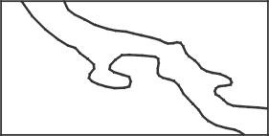 | Image Section  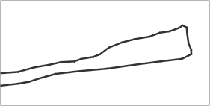

Explanation
as before

Translations
Croatian: Stijene kanala/ galerije
Dutch: gang-omlijning
French: Dessin de galerie
German: Gangumriss
Italian: Contorno della cavitr
Romanian: Conturul gaeriei
Slovene: Stene rova

Symbol: Underlying Passage
Image Plan  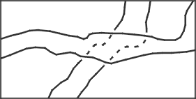 | Image Section  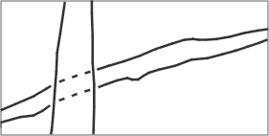

Explanation
As an additional help to distinguish the lower from the upper passage it is recommended to stop the line of the lower gallery before it reaches the upper gallery. To distinguish this symbol from the "presumed dimensions of space" (see below) it is recommended to draw short dashes with wide spacing.

Translations
Croatian: Kanal na nizoj etazi
Dutch: Onderliggende gang
French: Croisement de galeries
German: Unterlagernde Gänge
Italian: Cavitr sottoposta
Romanian: Galerii suprapuse
Slovene: Spodaj lezeci rov

Symbol: Too narrow Continuation
Image Plan  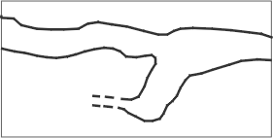 | Image Section  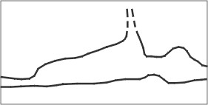

Explanation
as before

Translations
Croatian: Preuski prolaz
Dutch: te nauwe doorgang
French: Continuations trop étroites
German: Fortsetzung zu eng
Italian: Prosecuzione troppo stretta
Romanian: Impenetrabil
Slovene: Preozko nadaljevanje

Symbol: continuation Possible
Image Plan  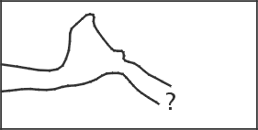 | Image Section  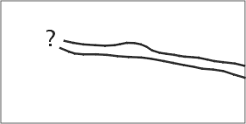

Explanation
as before

Translations
Croatian: Moguci nastavak
Dutch: mogelijke doorgang
French: Continuation possible
German: Fortsetzung möglich
Italian: Prosecuzione possibile
Romanian: Continuare posibila
Slovene: Mozno nadaljevanje

Symbol: Presumed dimensions of space
Image Plan  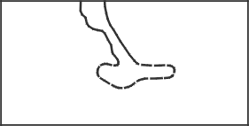 | Image Section  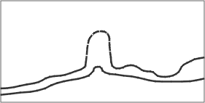

Explanation
as before. The dashes should be long and the spacing narrow (see "underlying passages").

Translations
Croatian: Pretpostavljena velicina kanala/ galerije
Dutch: Geschatte maten van de ruimte
French: Dimensions spatiales présumées
German: Geschätzte Gangdimensionen
Italian: Dimensioni presunte della cavitr
Romanian: Dimensiuni spatiale presupuse
Slovene: Predvidena veliksot prostora

Symbol: Ceiling form
Image Plan  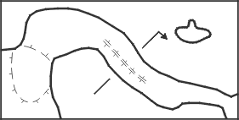 | Image Section  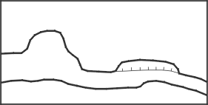

Explanation
The symbol for the form of the ceiling of a cave is also used for the dripline and for chimneys.

Translations
Croatian: Oblik stropa
Dutch: vorm van het plafond
French: Forme du plafond
German: Deckenform
Italian: Morfologia del soffitto
Romanian: Forma tavanului
Slovene: Oblika stropa

Symbol: Dripline - Profile
Image Plan  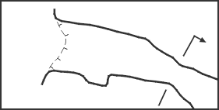 | Image Section  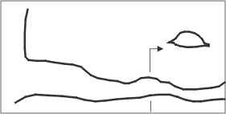

Explanation
The dripline can give valuable information especially for smaller caves and overhangs. It describes the actual entrance to a cave including the upper ceiling region and should therefore not be omitted. At the dripline the cave begins.
Cross-sections are of major importance for the understanding of a passage. For each map passage cross-sections must be drawn. The arrows indicating the direction of view are done differently, a clear indication is, however, necessary.

Translations
Croatian: kapnica (pocetak spilje) - Presjek
Dutch: druplijn - profiel
French: Entrée de cavité - Sections transversales
German: Trauflinie - Querschnitt
Italian: Limite esterno della grotta - Sezione trasversal
Romanian: Intrare-sectiune transversala
Slovene: Zunanja meja jame - profil

Symbol: Steps
Image Plan  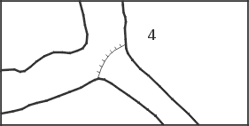 | Image Section  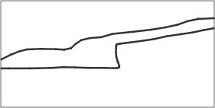

Explanation
This symbol is well known, just don't forget that the little dashes are always to be orientated downwards!

Translations
Croatian: Skok
Dutch: treden
French: Marches, ressauts
German: Stufen
Italian: Salto
Romanian: Saritoare
Slovene: Stopnja

Symbol: Pit
Image Plan  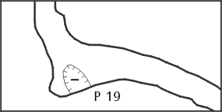 | Image Section  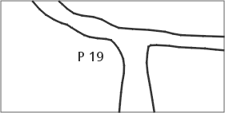

Explanation
The filled or empty triangle have been replaced by dashed lines for two reasons: First, the dashed line is easier to draw, secondly it is unclear even to most draughtsmen whether the empty triangles represent the smaller or the higher steps or when they should be filled (at 5 m or 10 m?).

Translations
Croatian: Vertikalni kanal (jama u objektu)
Dutch: Put/schacht
French: Puits (profondeur en mctres)
German: Schacht
Italian: Pozzo
Romanian: Put (adâncime în metri)
Slovene: Brezno

Symbol: Pit open to Surface
Image Plan  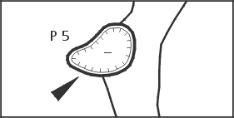 | Image Section  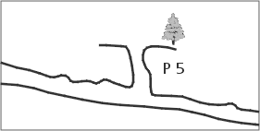

Explanation
as before

Translations
Croatian: Vertikalni ulaz (otvor jame)
Dutch: Put, Daglichtput
French: Puits débouchant en surface
German: Schacht mit Oberflächenöffnung
Italian: Pozzo 2
Romanian: Aven
Slovene: Vhodno brezno

Symbol: Aven/Aven-pitchs
Image Plan  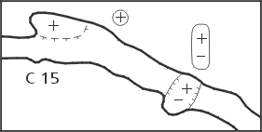 | Image Section  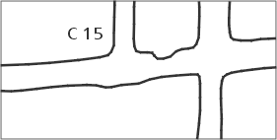

Explanation
The plus and minus signs can be written inside or outside the cave. For reasons of clearness they should be encircled when written outside the cave. We agreed to the following procedure to indicate the difficulty of a drop or a pitch: If the drop can be climbed without gear, there is only the number (in meters) written. If gear is needed, any letter precedes the number. This way, the use of most countries is respected. It is optional to draw the anchor points and ropes into the longitudinal section.

Translations
Croatian: Dimnjak/ Dimnjak iznad jame
Dutch: schoorsteen - put
French: Cheminée-Puits-cheminée
German: Schacht - Schlot
Italian: Camino - Pozzo-Camino
Romanian: Horn - Horn-put
Slovene: Kamin - brezno s kaminom

Symbol: Contourlines

Image Plan
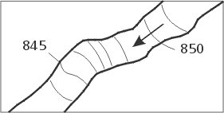

Explanation
Contour Lines (lines of same altitude) with altimetric measurement as done on geographic maps are seldom used, as the exact ground level is not always easily established and precise drawings can cause serious problems. Gradient lines are used more frequently.

Translations
Croatian: Slojnice sa oznacenom nadmorskom visinom
Dutch: Contourlijnen
French: Courbes de niveau
German: Höhenkurven
Italian: Curve di livello
Romanian: Curbe de nivel (altitudine în metri)
Slovene: Izohipse

Symbol: Gradient Arrows - Entrance Arrow

Image Plan
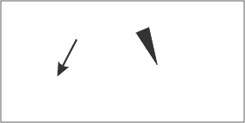

Explanation
The differentiation between gradient arrows inside and outside the cave is now omitted. An arrow indicating the entrance was added to the list.

Translations
Croatian: Smjer nagiba - Ulazna strelica
Dutch: Daal-pijlen Ingangs-pijl
French: Flcche de gradient - Flcche indiquant l'entrée de la cavité
German: Gefällepfeile - Eingangspfeil
Italian: Freccia di gradiente - Freccia per l'ingresso
Romanian: Directia de panta-Saggeata indicând intrarea
Slovene: Smer naklona - puscica za vhod

Symbol: Gradient Lines

Image Plan
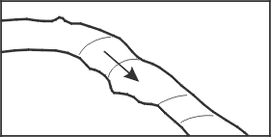

Explanation
Gradient lines are the most common methods to illustrate the ground structure. As on geographic maps narrow spacing indicates a steep and wide spacing a gentle slope.

Translations
Croatian: Slojnice (nagibne linije)
Dutch: Overgangslijnen
French: Lignes de gradient
German: Gefällelinien
Italian: Linee di Gradiente
Romanian: Linie de panta
Slovene: Naklonske crte

Symbol: Altitude above Sealevel

Image Plan
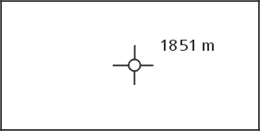

Explanation
This symbol has also been kept for reasons of consistence and designates the altitude above sea-level used in the map. It is highly recommended to write 1880 m. instead of just writing 1880. Generally maps are all to be done in SI units.

Translations
Croatian: Nadmorska visina (m.n.m)
Dutch: Hoogte boven zeeniveau
French: Altitude au-dessus du niveau de la mer
German: Höhenangaben (Seehöhe)
Italian: Quota s.l.m.
Romanian: Altitudini deasupra nivelului marii
Slovene: Nadmorska visina (m.n.m.)

Symbol: Difference in Elevation

Image Plan
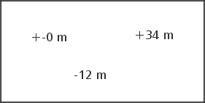

Explanation
in Relation to the entrance, as before

Translations
Croatian: Visinska razlika
Dutch: Hoogteverschil
French: Altitude relative r l'entrée de la cavité
German: Höhendifferenz
Italian: Differenza di quota
Romanian: Altitudine relativa de la intrare
Slovene: Visinska razlika

Symbol: Joint - Fault - Bedding Plane - Inclined Joint

Image Plan
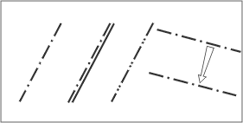

Explanation
These symbols can be quite important for the understanding of the cave. Please use the symbols proposed here only when there's no appropriate set of symbols at the geological survey of your country. It is also recommended not to use any geological symbol unless one is totally sure about its nature. The arrow connecting two joint symbols is normally only used in the plan. It shows whether a cave crosses the same joint several times or whether it follows the joint itself.

Translations
Croatian: Pukotina - Rasjed - Geoloski sloj - Nagnuta pukotina
Dutch: Breuk - Verschuiving - Laagvoeg
French: Fracture - faille - joint de strate - fracture inclince
German: Kluft - Verwerfung - Schichtfuge - schräge Ebene
Italian: Frattura-Faglia-Stratificazione
Romanian: Fractura-Falie-Fata de strat-Fractura înclinata
Slovene: Razpoka - prelom - geoloska plast - nagnjena razpoka

Symbol: Lake - Flowing Water
Image Plan  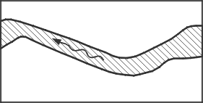 | Image Section  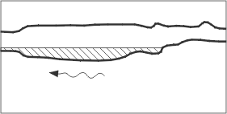

Explanation
as before

Translations
Croatian: Jezero - Vodeni tok
Dutch: Meer - Stromend water
French: Lac-eau courante
German: Seen und fliessende Gewässer
Italian: Lago-Corso d'acqua
Romanian: Lac - apa curgatoare
Slovene: Jezero - vodni tok

Symbol: Sump
Image Plan  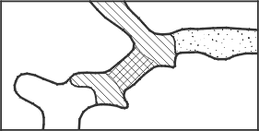 | Image Section  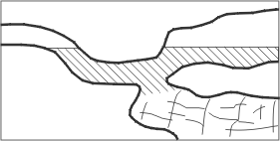

Explanation
as before. As an option it is possible to stop the crosshatching in order to draw the characteristics of the sump. This possibility, especially useful in longer sumps, is also shown.

Translations
Croatian: Sifon
Dutch: sifon/watergevulde gang
French: Siphon
German: Siphon
Italian: Sifone
Romanian: Sifon
Slovene: Sifon

Symbol: Cascade - Waterfall
Image Plan  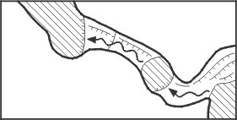 | Image Section  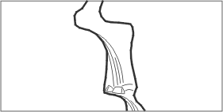

Explanation
The symbol for waterfall is the same as the one for drop. To show flowing water one can draw an arrow indicating the flow before or at the side.

Translations
Croatian: Vodopad
Dutch: Cascade - Waterval
French: Cascade / Chute d'eau
German: Wasserfall
Italian: Cascata
Romanian: missing
Slovene: Slap

Symbol: Spring - Sink
Image Plan  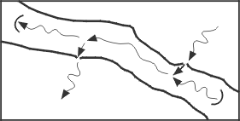 | Image Section  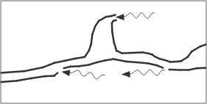

Explanation
Springs or sinks which flow sideways in or out of a cave don't need a half circle to be characterised, whereas water inlets and outlets in the ground should be marked with a half-circle to distinguish them clearly from normal flowing water.
Symbols for temporary waters of all kinds have been omitted alltogether because of the following reasons: Hydrologically many water courses are also dry in dry times and are therefore also temporary. Adding to that, there have been many different symbols in the old symbol lists that would severely extend this list. One may add a note on temporary waters to the cave description.

Translations
Croatian: Izvor - Ponor
Dutch: Bron - verdwijnpunt
French: Source / perte
German: Quelle - Ponor
Italian: Sorgente - Inghiottitoio
Romanian: Izvor - Ponor-Pierdere de apa
Slovene: Izvir - ponor

Symbol: Widespread Water Inlet - Seeping
Image Plan  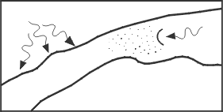 | Image Section  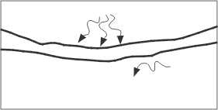

Explanation
There is no special symbol any more. It is needed to draw several ± parallel arrows indicating the flow. For seeping of a watercourse in sediment the semicircle is also used in the plan! In the longitudinal section the direction of the arrow can be bent towards the bottom to hint the seeping.

Translations
Croatian: Razveden dotok vode - Sitasti ponor
Dutch: wijdverspreide waterinvoer - sijpels
French: Arrivée d'eau diffuse - Suintement d'eau dans un sédiment
German: Tropfwasser - Sickerwasser
Italian: Afflusso d'acqua diffuso - Infiltrazione nel detrito
Romanian: Aport de apa difuz - Infiltratii
Slovene: Razvejan pritok vode - ponikujoca voda

Symbol: Scallops, Flutes in General, Direction of Paleoflow
Image Plan  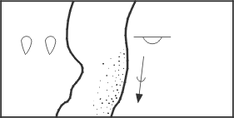 | Image Section  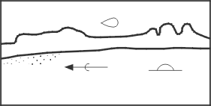

Explanation
Flow Casts (Scallops): as before.
Flute: The differentiation between erosional and corrosion flutes has been omitted, because, especially with flutes on lateral walls, they cannot always be identified correctly. The new symbol can be rotated; if the semicircle is on top, it shows a flute on the ceiling, etc.
Paleoflow: This very useful symbol is not only used with scallops, but also with ripple marks, imbrications and other features. In addition it might be used in lava caves to show the flow direction of the lava.

Translations
Croatian: Vrtlozni lonci - Zljebici (fasete) - Smjer fosilnog toka
Dutch: Erosie koepels, kolkgaten, richting van de paleo-stroom
French: Coupoles d'érosion - marmites - courant d'ccoulement fossile
German: Kolke - Fliessfacetten - Paläofliessrichtung
Italian: Scallops - Scanellature in general - Direzione del paleoflusso
Romanian: Cupole de eroziune - marmite - curent de apa fosil
Slovene: Kotlice - zlebici (fasete) - smer starega toka.

Symbol: Air draught - Ice/Snow/Firn
Image Plan  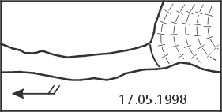 | Image Section  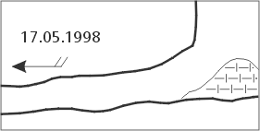

Explanation
Air draught: This is a well known symbol. It should always include the date of measurement. The symbol now uses always two feathers! The date of measurement should be written in the standard dd-mm-yyyy format!
Ice/Snow/Firn: The old star symbol used for snow hasn´t been satisfactory for quite some time as it is very time consuming to draw and the ground structure cannot be shown. Added to this, it can easily be mistaken for the crystal symbol. The old symbol for ice is confusingly similar to true gradient lines. Taking all this into consideration we agreed on the following solution: Snow is transformed to firn and subsequently to ice. By morphology and composition all three substances are the same, therefore it should be represented by the same symbol. The one that has been chosen is easy to draw, shows the ground structure and cannot be mixed up.

Translations
Croatian: Propuh - Led/Snijeg/Inje
Dutch: luchtstroom - Ijs-Sneeuw-firn
French: Courant d'air - Glace/neige/givre
German: Luftzug - Eis/Schnee/Firn
Italian: Corrente d'aria - Ghiaccio - Neve - Firn
Romanian: Curent de aer - Gheata-zapada-firn
Slovene: Prepih - led/sneg/srez

Symbol: Stalagmites
Image Plan  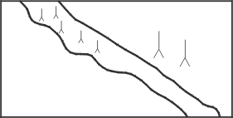 | Image Section  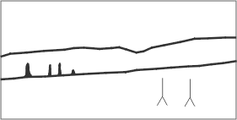

Explanation
as before

Translations
Croatian: Stalagmiti
Dutch: Stalagmieten
French: Stalagmites
German: Stalagmiten
Italian: Stalagmiti
Romanian: Stalagmite
Slovene: Stalagmiti

Symbol: Stalactites
Image Plan  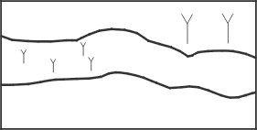 | Image Section  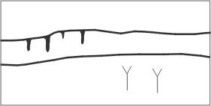

Explanation
as before

Translations
Croatian: Stalaktiti
Dutch: Stalactieten
French: Stalactites
German: Stalaktiten
Italian: Stalattiti
Romanian: Stalactite
Slovene: Stalaktiti

Symbol: Sinter Curtains - Pillars
Image Plan  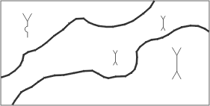 | Image Section  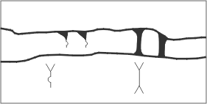

Explanation
Calcite Curtains: The presented solution is not easily understood at first sight but seems to be the best (alternatively you draw the curtains into your map).
Calcite pillars: as before

Translations
Croatian: Zavjese od sigovine - Stupovi
Dutch: Gordijnen - Pilaren
French: Draperies stalagmitiques - Piliers stalagmitiques
German: Sintervorhänge - Tropfsteinsäulen
Italian: Cortina di concrezione - Colonna
Romanian: Draperii stalagmitice - coloane-pilieri stalagmitici
Slovene: Sigova zavesa - steber

Symbol: Helictites - Soda Straws - Crystals
Image Plan  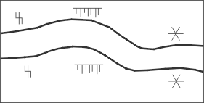 | Image Section  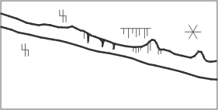

Explanation
Helictites: This symbol is as eccentric as the formation itself and is therefore easily understood.
Soda Straws: This symbol doesn´t need any further explanations.
Crystals: For reasons of international understanding the letters identifying the minerals should be avoided, first because correct mineral identification is often not as easy as it may seem, and second because a C for calcite is an K in German and a # in Chinese. In general we do not recommend the use of letters as symbols on the actual map. The resulting babylonic confusion can be lethal for the understanding.

Translations
Croatian: Heliktiti - Spageti - Kristali
Dutch: excentrieken - macaronies - kristallen
French: Excentriques/Helictites - Spaghettis - Cristaux
German: Excentriques - Spaghetti - Kristalle
Italian: Concrezione eccentrica - Spaghetti - Cristalli
Romanian: Excentrite-Helictite - macaroane - cristale
Slovene: Heliktiti - spageti (cevcice) - kristali

Symbol: Sinter Pools
Image Plan  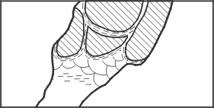 | Image Section  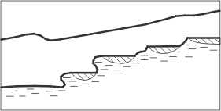

Explanation
as before

Translations
Croatian: Zasigane kaskade
Dutch: Sinter-bekkens
French: Gours
German: Sinterbecken
Italian: Grandi vasche - Vaschette di concrezione
Romanian: Gururi
Slovene: Sigove ponvice

Symbol: Flowstone - Wall Calcite - Moonmilk
Image Plan  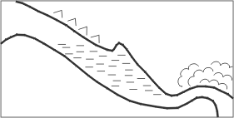 | Image Section  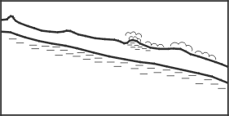

Explanation
Flowstone: Often this or a similar symbol is also used for clay (see there).
Wall Calcite: as before
Moonmilk: To avoid mistaking this symbol for the guano symbol an additional bow has been added to the usual m.

Translations
Croatian: Zasigano tlo - Zasigana stijena - Spiljsko mlijeko
Dutch: Bodemdruipsteen - afzettingen op de wand - bergmelk
French: Concrétionnement au sol - Concrétionnement sur les parois - Mondmilch
German: Bodensinter - Wandsinter - Mondmilch (Bergmilch)
Italian: Colata a pavimento - Colata parietale - Latte di Monte
Romanian: Planseu concretionat - concretiuni parietale - montmilch
Slovene: Zasigano pobocje - zasigana stena - jamsko mleko

Symbol: North Arrow Geographic and Cartesic

Image Plan
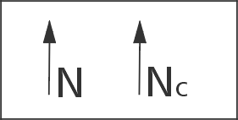

Explanation
On several maps, information on declination is missing or is incomplete, which makes the calculation of geographic north almost impossible. Beside the normal North arrow one must specify whether one relates to geographic, magnetic, or cartographers north. If one is relating to magnetic north the date of measurement must be mentioned. Both versions shown are equivalent.

Translations
Croatian: Zemljopisni (geografski) i Kartezijski sjever
Dutch: Noord pijl Geografisch en Cartesisch
French: Nord géographique et cartographique
German: Geographisch und Kartesisch Nord (Gitternord)
Italian: Nord Geografico et Cartesiano
Romanian: Directia nord - geografic and cartigrafic
Slovene: Geografski sever - Kartezijski sever

Symbol: North Arrow Magnetic

Image Plan
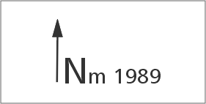

Explanation
On several maps, information on declination is missing or is incomplete, which makes the calculation of geographic north almost impossible. Beside the normal North arrow one must specify whether one relates to geographic, magnetic, or cartographers north. If one is relating to magnetic north the date of measurement must be mentioned.

Translations
Croatian: Magnetski sjever
Dutch: Noordpijl Magnetisch Noorden
French: Nord magnétique
German: Magnetisch Nord
Italian: Nord Magnetico
Romanian: Directia nord magnetic
Slovene: Magnetni sever

Symbol: Blocks - Debris
Image Plan  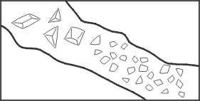 | Image Section  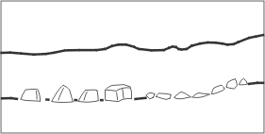

Explanation
as before. The size can be modelled on the reality.

Translations
Croatian: Blokovi - Krslje
Dutch: Blokken - rol-steentjes
French: Blocs, débris
German: Blockwerk, Geröll
Italian: Massi - Detriti a spigoli vivi
Romanian: Blocuri - prabusiri
Slovene: Bloki - grusc

Symbol: Pebbles
Image Plan  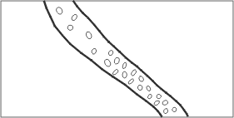 | Image Section  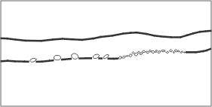

Explanation
as before. The size can be modelled on the reality.

Translations
Croatian: Sljunak
Dutch: Kiezels
French: Cailloux
German: Kiesel
Italian: Ciottoli - Detriti a spigoli arrotondati
Romanian: Pietris
Slovene: Prodniki

Symbol: Clastic sediments: Sand - Silt - Clay - Humus
Image Plan  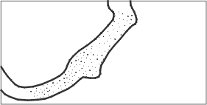 | Image Section  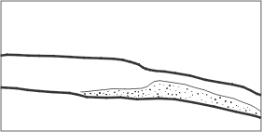

Explanation
With the exception of humus this group is a sediment whose grain size and therefore names depend on the velocity of current of the carrying water. In flowing water sand is deposited whereas in standing water clay is deposited. In contrast to this the flowstone (see there), which is a chemical precipitchation, does not represent the velocity of flow but the chemical equilibrium. As flowstone occurs quite frequently a special symbol needed to be found. The small parallel dashes did a good job as they also showed the ground structure. Unfortunately several surveyors characterised clay by a series of small dashes, which can lead to some confusion.

Translations
Croatian: Klasticni sedimenti: Pijesak - Mulj - Glina - Humus
Dutch: Sedimenten: Zand - Zilt - Klei/Leem - Humus
French: Sédiments clastiques : Sable, limon, argile et humus
German: Klastische Sedimente: Sand - Schlamm - Lehm - Erde
Italian: Sedimento fine: Sabbia - Limo - Argilla - Humus
Romanian: Sediment clastic - nisip, mâl, argila, humus
Slovene: Klasticni sedimenti: Pesek - mulj - glina (blato) - prst

Symbol: Clay-Covered Walls
Image Plan  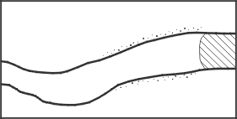 | Image Section  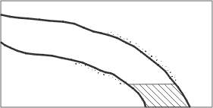

Explanation
This symbol can be used to show flooded zones. To show a mud coating, one thin dotted line is drawn behind the cave walls.

Translations
Croatian: Glinom prekrivene stijene
Dutch: Klei-bedekte wanden
French: Parois couvertes d'argile
German: Lehmüberzogene Wände
Italian: Pareti ricoperte di argilla
Romanian: Pereti acoperiti cu argila
Slovene: Z glino prekrite stene

Symbol: Guano
Image Plan  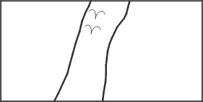 | Image Section  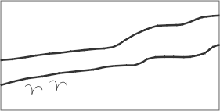

Explanation
as before

Translations
Croatian: Guano
Dutch: Guano
French: Guano
German: Guano
Italian: Guano
Romanian: Guano
Slovene: guano

Symbol: Camp
Image Plan  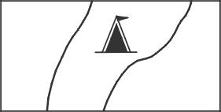 | Image Section  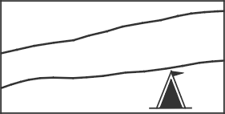

Explanation
as before

Translations
Croatian: Bivak
Dutch: Kamp/Bivak
French: Camp
German: Biwak
Italian: Campo, Bivacco
Romanian: Tabara
Slovene: bivak

Symbol: Height of a Room

Image Plan
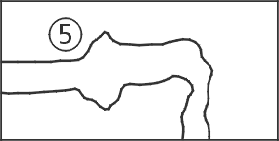

Explanation
An indication on height can be useful for a caver who doesn´t draw longitudinal sections. But since this is highly recommended (see documentation of the 9. National Nongress 991, Charmey) this symbol is not going to be used very often.

Translations
Croatian: Visina galerije
Dutch: Hoogte van een zaal
French: Hauteur d'une galerie / salle
German: Raumhöhe
Italian: Altezza di un ambiente
Romanian: Înaltime (alerie-sala)
Slovene: Visina prostora

Symbol: Anostomosen - Karren
Image Plan  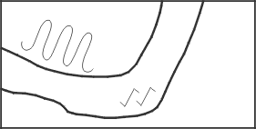 | Image Section  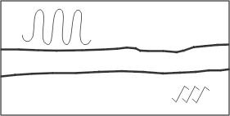

Explanation
as before

Translations
Croatian: Anastomoza - Skrape
Dutch: Vlechtende micro-gangetjes - Karren
French: Anastomoses - Lapiez
German: Anostomosen - Karren
Italian: Anastomosi - Karren
Romanian: Anastomoze - lapiezuri
Slovene: Anastomoza - skraplje

Symbol: Cauliflower-Calcite / Disk
Image Plan  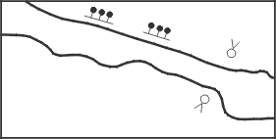 | Image Section  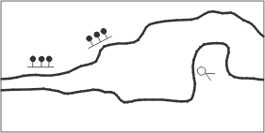

Explanation
These two symbols for calcite are of a regional importance and can be quite useful.

Translations
Croatian: Karfioli - Nakapne ploce
Dutch: Kalk-bloemkool - Disk
French: Concrétionnement en choux-fleurs - Disques
German: Blumenkohlsinter / Disk
Italian: Cavolfiori - Dischi di concrezione
Romanian: Clusterite-Coralite - discuri
Slovene: Karfjolce - kapniske plosce

Symbol: Bones
Image Plan  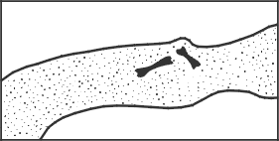 | Image Section  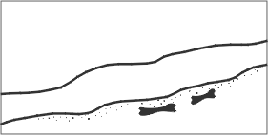

Explanation
This symbol does not need any further explanation.

Translations
Croatian: Kosti
Dutch: Botten
French: Ossements
German: Knochen
Italian: Ossa
Romanian: Oase
Slovene: kosti

Symbol: Human Activity
Image Plan  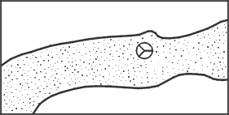 | Image Section  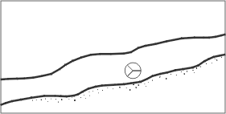

Explanation
This symbol is used for man-made changements and/or relicts in caves, including e.g. artwork / drawing / pottery / old mining sites / human bones. Preferably, it will be used for historic/prehistoric changements!

Translations
Croatian: Ljudska aktivnost
Dutch: Menselijke activiteit
French: Traces d'activité humaine
German: Menschliche Artefakte
Italian: Modificazioni umane
Romanian: Urme de activitate antropica
Slovene: Clovekove spremembe oz. ostanki

Tomado de: http://www.earthsci.unibe.ch/people/praezis/symbol2.html
http://www.earthsci.unibe.ch/people/praezis/symbol1.html

A proposition for Karst surface conventional symbols

Karst surface symbols, used mainly by geomorphologists, but sometimes also by geologists, contain important information on a map. Until now, however, the surface symbols were only partly standardised, often on a national (or even organisational) scale. This led to a possible misunderstanding of the map or to a difficult reading that needed to consult the legend very often. The utility to standardize the karst surface symbols is therefore given.
The following propositions had been elaborated on the base of several regional or national lists, most of them coming from Europe. Two of the main contributors are the work of F. JOLY and A. BINI et al., that were completed and partially adapted to the Swiss Geologic conventional signs, and the old UIS entrance symbol set. The present proposition's aim is:
- to be a base of information. This means that the present list is by no means complete, but should constitute a sound base, upon which the individual countries and/or organisations can build up their own symbol list they need for their specific maps
- therefore to stimulate discussions amongst karst geomorphologists and geologists
- to get to a generally adopted, universally acknowledged symbol set that will facititate the reading of geomorphologic maps.
It therefore follows the UIS Cave Signatures which had been elaborated on the same way.
The present proposition had been elaborated by the UISIC Working group Survey and Mapping, in contact with the IGU Karst Commission and other interested persons. Attention has been paid that the presented symbols can be generated or propagated by computer programs, since most of today's cartography is computer-aided.
The author of the present list kindly asks for suggestions, improvements, and comments on the present proposition!
The address is:
Ph. Haeuselmann Haldenstr. 32, 3014 Bern - Switzerland, 0041 31 3320174, praezis@geo.unibe.ch

